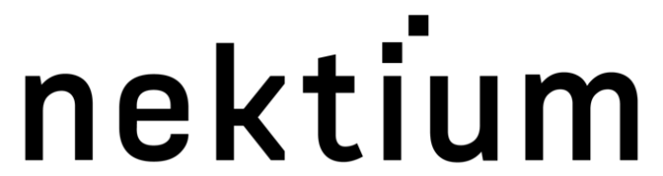

5 June 2023

PRESS RELEASE

Nektium expands international distribution network
for botanical extracts

Nektium has announced three new global distribution partnerships for its clinically researched, branded botanical extracts.
Founded in 1997, Nektium offers a botanical ingredient portfolio including the Rhodiola rosea extract Rhodiolife® and the patented mango leaf extract Zynamite®.
The Spain-based company has now confirmed two distribution agreements in Europe and one in Japan as part of its long-term strategy to grow international sales.
Food ingredient and nutraceutical distribution specialist Deimos will distribute Nektium’s portfolio in Italy – the largest European market for nutraceuticals in terms of spending per capita – and San Marino.
Nektium has also formalized its existing 10-year partnership with French plant extract specialist Becarre Natural, which will now be the exclusive distributor of its products throughout France, Belgium, and Luxemburg.
In addition, supplement specialist Ryusendo has signed a Japanese distribution agreement for Rhodiolife®, which it launched at ifia/HFE Japan in May. The strategic partnership will see Ryusendo conducting proprietary work and potentially its own scientific research into the benefits of Rhodiolife®.
Bruno Berheide, Commercial & Partnerships Director at Nektium, said: “Over the last two decades, we have built a robust network of trusted commercial partners and strategic allies based on shared values and business ethics. We are therefore delighted to be strengthening our international presence through our new distribution deals with Deimos, Becarre Natural, and Ryusendo. Their considerable market knowledge and technical and regulatory expertise will enable us to reach new customers and drive sales over a wider range of territories.”
The deals follow Nektium’s recent expansion beyond the dietary supplement and nutraceutical categories and into the more mainstream food and beverage sector. This means its ingredients can now be used in a wide range of applications, including sports and energy drinks, dairy products, gummies, and cereal bars. ​
ENDS
For more information please contact:
Robin Hackett, Ingredient Communications
Tel: +44 (0) 7507 277733 | Email: robin@ingredientcommunications.com

About Nektium
Based on the island of Gran Canaria, Spain, Nektium specializes in the supply of branded and generic botanical ingredients of the highest quality. The business was born out of two friends’ shared passion for the phytochemistry and pharmacology of botanicals and their applications in health and wellness. When it was first established in 1997, little was known about many of these botanical extracts, but the team at Nektium made it their mission to explore and unleash their potential health benefits. Today, the company is still defined by this solid foundation of dedicated relationships and its love for nature and research. Nektium’s flagship products are Zynamite®, a proprietary mango leaf extract (Mangifera indica), Rhodiolife®, a rhodiola plant extract (Rhodiola rosea) as well as Xanthigen®, a proprietary botanical blend for weight management.

